**SQL problem:**

We have a table ProductSales with columns: ProductID (INT), SaleAmount (DECIMAL), and SaleMonth (VARCHAR, e.g., 'Jan', 'Feb', 'Mar', 'Apr').

Write an SQL query to display the total SaleAmount for each ProductID, with separate columns for the sales of 'Jan', 'Feb', and 'Mar'. The output should have one row per ProductID and columns for each month.

**Table: ProductSales**

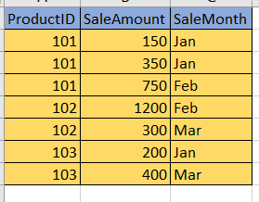

**Expected output:**

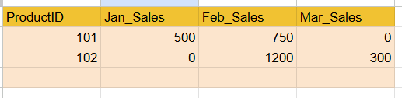

**SQL Query:**

```

select ProductID,

sum(case SaleMonth when 'Jan' then SaleAmount else 0 end) as 'Jan_Sales',

sum(case SaleMonth when 'Feb' then SaleAmount else 0 end) as 'Feb_Sales',

sum(case SaleMonth when 'Mar' then SaleAmount else 0 end) as 'Mar_Sales'

from ProductSales

group by ProductID;

```